Edge detection techniques

**The Original image**



**1-Apply “The Sobel filter”** ,creates an image which emphasizes edges and transitions.

It is a discrete differentiation operator that computes an approximation of the gradient of the image intensity function. At each point in the image, the result of the Sobel operator is either the corresponding gradient vector or the norm of this vector.

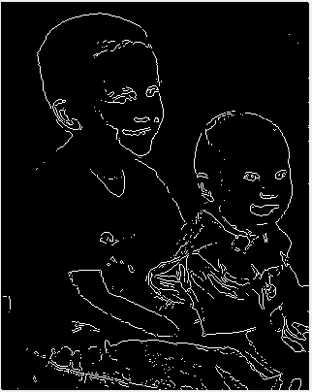

**2-SECOND DERIVATIVE / ZERO CROSSING (LAPLACIAN)**

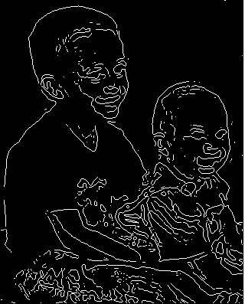

**3-Apply the Canny method.**

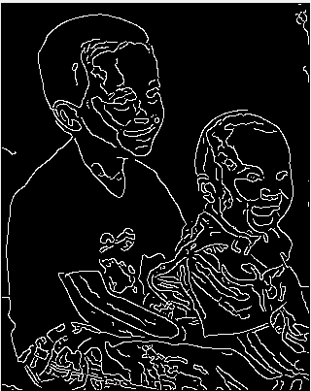

**The different between The Three Methods**

Canny method out performs all the other methods even though its computational complexity is higher. Canny can be used for the extraction of even objects with feeble edges